2D Geometric Modeling
Chapter
5

Introduction
The 2 Dimensional Geometric Modeling Package provides geometric modeling services for two dimensional shapes and sections. Shape and section models are analysis models that can be used to compute geometric properties, such as cross sectional area and moment of inertia.
A shape is a representation of the boundary contour of something. A shape could represent the boundary of a section through a structural member or the boundary of a parcel of land. Composite shapes composed of primitive geometric shapes, such as circles and polygons, can be created to represent complex shapes. The geometric properties of primitive and complex shapes can be computed.
A section is a representation of an element in a structure as it would appear if cut by an intersecting plane, so that the internal components are displayed. A section consists of a collection of components. Each component has a shape, material properties (modulus of elasticity and density), and a usage indicator (structural/non-structural). A section cut through a rectangular reinforced concrete beam, for example, would consists of a rectangle shape for the concrete beam, circular shapes for the reinforcement, circular shapes for the holes in the concrete made by the reinforcement, and the material properties of the concrete and reinforcing steel. All of the components in this reinforced concrete section are structural in nature.
The section modeling package can be used to compute the following properties:
- Elastic stiffness properties
- Transformed section properties
- Mass properties
In general, shape and section models are ignorant of bridge domain knowledge. The notions of reinforced concrete, slab on beam sections, built-up plate girders, and the like are foreign to these analytical models. Higher level packages should use the services of this package to compute domain specific section properties, such as second moment or area (Q) for composite slabs.

Logical Design

Static Models
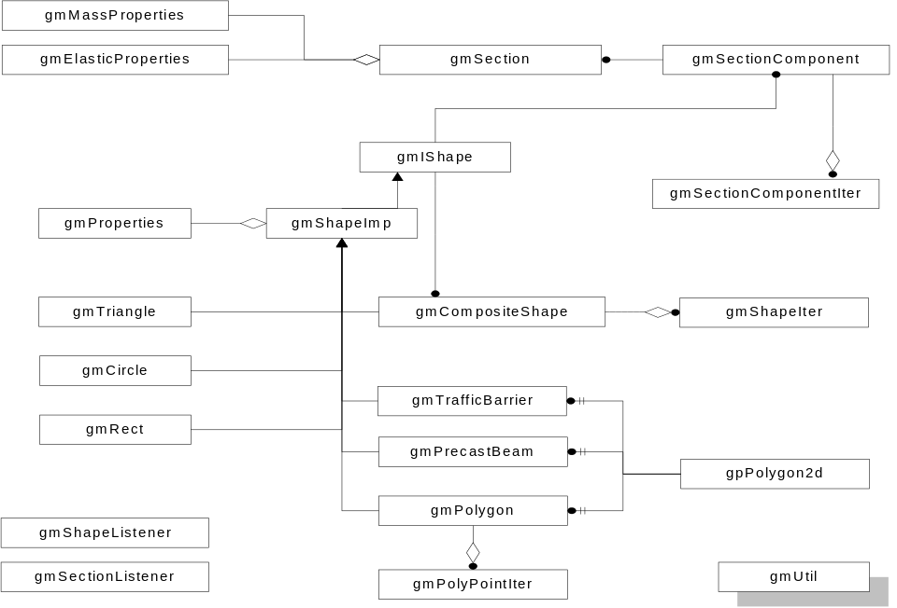

Dynamic Models

Physical Design
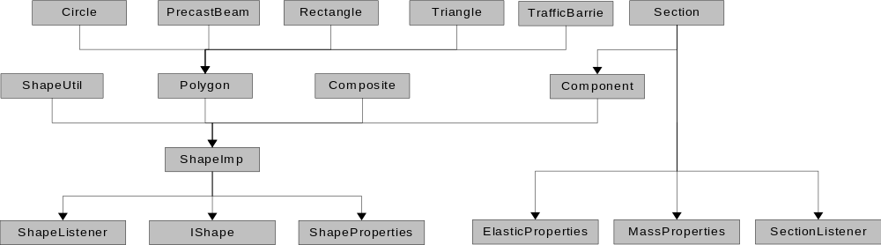
Component | Classes in Component
ShapeProperies | gmProperties
ElasticProperties | gmElasticProperties
MassProperties | gmMassProperties
IShape | gmIShape
ShapeImp | gmShapeImp
ShapeListener | gmShapeListener
Circle | gmCircle
Polygon | gmPolygon  gmPolyPointIter
Rectangle | gmRectangle
Triangle | gmRectangle
Composite | gmCompositeShape  gmShapeIter  gmConstShapeIter
TrafficBarrier | gmTrafficBarrier
PrecastBeam | gmPrecastBeam
Section | gmSection  gmSectionComponentIter  gmConstComponentIter  gmSectionComponent
SectionListener | gmSectionListener
Util | gmUtil

Component | Level | Number of components that must be developed in order to test this component.
ShapeListener | 1 | 1
SectionListener | 1 | 1
Util | 3 | 4
ShapeProperties | 1 | 1
ElasticProperties | 1 | 1
MassProperties | 1 | 1
IShape | 1 | 1
ShapeImp | 2 | 4
Circle | 4 | 6
Polygon | 3 | 5
Rectangle | 4 | 6
Triangle | 4 | 6
Composite | 4 | 6
Component | 3 | 5
TrafficBarrier | 4 | 6
PrecastBeam | 4 | 6
Section | 4 | 10
N |  | 17
CCD |  | 60
ACD |  | 3.529
CCD_{Balanced Binary Tree} |  | 58.1
NCCD |  | 1.03

Specifications

gmIShape
This pure abstract base class provides a framework for extending the shape modeling package through interface inheritance. All member functions in this class are pure virtual. Subclass authors must implement the interface to create a specific shape type. The gmShapeImp class directly implements many of the functions in gmIShape and provides a framework that gmShapeImp derived shapes can use to easily implement the entire gmIShape interface. Most new shape classes should be derived from gmShapeImp and not directly from gmIShape.
In addition to the interface specified below, this class supports the standard broadcaster interface.

Public Interface - Member Functions
Translate
virtual void Translate(const gpSize2d& delta)=0;
Translates a shape by a delta amount.
Move
virtual void Move(LocatorPoint from, const gpPoint2d& to)=0;
virtual void Move(const gpPoint2d& from, const gpPoint2d& to)=0;
Move a shape by moving from one point in space to another.
Rotate
virtual void Rotate(const gpPoint2d& center, Float64 angle)=0;
Rotates a shape. The rotation is centered about point center. The rotation, angle is measured in radians counter clockwise.
GetProperties
virtual void GetProperties(gmProperties* pProperties) const =0;
Assigns a gmProperties object to the object pointed to by pProperties. The origin of the shape properties object is the centroid of this shape with a rotation of zero.
GetBoundingBox
virtual gpRect2d GetBoundingBox() const =0;
Returns the smallest rectangle that bounds the entire shape.
GetLocatorPoint
virtual gpPoint2d GetLocatorPoint(LocatorPoint point) const =0;
Returns a point located at the specified location on the bounding box around the shape.
IsContained
virtual gmIShape::Containment IsContained(const gpPoint2d& p) const = 0;
Tests if point p is contained within the boundary of the shape. Returns the containment state of point p.
Implement only if needed.
CreateClone
virtual gmIShape* CreateClone(bool bRegisterListeners = false) const =0;
Creates a clone of this broadcaster. If bRegisterListeners is true the listeners are registered with the clone. This is a factory method, you are responsible for freeing the memory allocated by this method.
CreateClippedShape
virtual gmIShape* CreateClippedShape(const gpLine2d& line,
gpLine2d::Side side
) const = 0;
Clips this shape against line. Returns the portion of the shape on the side of the line defined by side. This is a factory method. You are responsible for freeing the memory allocated by this method. If the shape lies entirely on the clipping side of the line 0 is returned. Any listeners to the original section are not transferred to this new section.
CreateClippedShape
virtual gmIShape* CreateClippedShape(const gpRect2d& r,
gmIShape::ClipRegion region
) const = 0;
Clips this shape against rectangle r. Clips in or out of the rectangle as specified by region. This is a factory method. You are responsible for freeing memory allocated by this method. This method returns 0 if, the shape lies entirely within the clipping rectangle and region is set to clip out, or the shape and the rectangle do not intersect and region is to clip in. Any listeners to the original section are not transferred to this new section.
GetFurthestDistance
virtual Float64 GetFurthestDistance(const gpLine2d& line,
gpLine2d::Side side) const = 0;
Returns the distance to a line that is parallel to line, on specified side of line, that passes through the furthest point on the shape from line.
MakeSolid
virtual void MakeSolid(bool bIsSolid=true) =0;
Makes this shape represent a solid area.
IsSolid
virtual bool IsSolid() const =0;
Returns true if this shape represents a solid, otherwise returns false.
GetPerimeter
virtual void GetPerimeter(gpPoint2dVector& vPoints) const = 0;
This method fills the supplied gpPoint2dVector (typedef for std::vector<gpPoint2d>) with a polygonal representation of the perimeter of this shape.
Do not implement until a need is shown
BorderMode
virtual bool EnableBorderMode(bool bEnable) =0;
Enable/disables the border drawing mode of the shape. If bEnable is true, a border will be drawn around the shape in the border color. Border mode is enabled by default. Returns the previous border mode setting.
IsBorderModeEnabled
virtual bool IsBorderModeEnabled() const =0;
Returns true if the border mode is enabled, otherwise false.
SetBorderColor
virtual COLORREF SetBorderColor(COLORREF color) =0;
Sets the border color to color. Returns the previous color setting. Notifies listeners through the OnDisplayAttributesChanged() method.
GetBorderColor
virtual COLORREF GetBorderColor() const =0;
Returns the border color.
EnableFillMode
virtual bool EnableFillMode(bool bEnable) =0;
Enables/disables the fill mode of the shape. If bEnable is true, the shape will be filled with the fill color. Fill mode is enabled by default. Returns the previous fill mode setting.
IsFillModeEnabled
virtual bool IsFillModeEnabled() const =0;
Returns true if the fill mode is enabled, otherwise false.
SetFillColor
virtual COLORREF SetFillColor(COLORREF color) =0;
Sets the fill color to color. Returns the previous color setting. Notifies listeners through the OnDisplayAttributesChanged() method.
GetFillColor
virtual COLORREF GetFillColor() const =0;
Returns the fill color.
Draw
virtual void Draw(HDC hDC, const grlibPointMapper& mapper) const = 0;
Draws the shape on the given device context. Mapping of the coordinates to the device space should be done using the supplied point mapper.
Draw is for static displays only. The drawing of this analytical model is not intended for interactive, graphical editing. Interactive graphical editing is best left for a package specifically designed for this purpose, such as jKit/GO. In a package like jKit/GO, a GO object would most likely delegate its drawing responsibility to the gmIShape object it represents.
Subject to removal if we can ever figure out the MVC stuff
GetComposite
virtual gmCompositeShape* GetComposite() =0;
virtual const gmCompositeShape* GetComposite() const =0;
Returns a pointer to the composite interface if this shape supports it, otherwise returns 0. The default implementation of this method is to return zero. If your subclass supports the gmCompositeShape interface, and you wish to expose it, override this method and return a pointer to your implementation of the gmCompositeShape interface.
GetParent
virtual gmCompositeShape* GetParent() =0;
virtual const gmCompositeShape* GetParent() const =0;
Returns a pointer to the parent composite if this shape is a member of a composite, otherwise returns 0.
SetParent
virtual void SetParent(gmCompositeShape* pParent) = 0;
Called by gmCompositeShape when inserted into a composite. pParent must be returned in any subsequent calls to GetParent().
NotifyAllListeners
virtual void NotifyAllListeners(Int32 hint) = 0;
This method provides subclassed shapes a method of notifying listeners through the base class interface. Derived versions of this class must also call NotifyAllListeners() of their parent if they are in a composite.

Public Interface - Enumerations
Containment
enum { Inside, Outside, Boundary, Surrounded } Containment;
Defines the containment state of a point.
Only if IsContained() is implemented.
We could have a problem implementing IsContained() for composite shapes. Using the implementation we had before, calling IsContained() on the following shape will return an incorrect result.
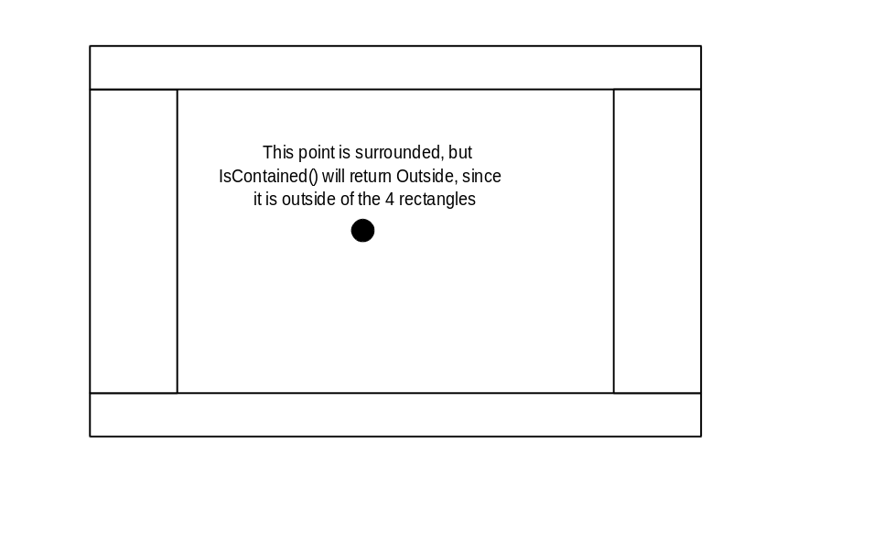
This is a good reason not to implement IsContained(). This is basically the same reason we aren’t implementing IsConsistent().
ClipRegion
enum { In, Out } ClipRegion
Defines the region of a rectangle that a shape should be clipped against.
LocatorPoint
enum LocatorPoint {TopLeft, TopCenter, TopRight,
CenterLeft, CenterCenter, CenterRight,
BottomLeft, BottomCenter, BottomRight}
Defines the major locator points on a bounding rectangle.

gmShapeImp
This abstract base class, which is derived from gmIshape, provides a framework for extending the shape modeling package through implementation inheritance. Subclass authors must implement the remainder of the gmIShape interface that is not implemented by this class.
This class is designed to provide a implementation framework for concrete gmIShape-derived classes. If you plan to extend gmIShape, you should also consider extending this class as well.

Public Interface - Member Functions
gmShapeImp
gmShapeImp();
Default constructor. Initializes the shape.
~gmShapeImp
virtual ~gmShapeImp ();
Destructor.
Translate
virtual void Translate(const gpSize2d& delta);
Moves the shape by a delta amount. Calls DoMoveBy().
Move
virtual void Move(LocatorPoint from,
const gpPoint2d& to);
virtual void Move(const gpPoint2d& from,
const gpPoint2d& to);
Move a shape by moving from one point in space to another.
Rotate
void Rotate(const gpPoint2d& center, Float64 angle);
Rotates a shape. The rotation is centered about point center. The rotation angle is measured in radians counter clockwise.
GetLocatorPoint
gpPoint2d GetLocatorPoint(LocatorPoint point) const;
Returns a point located at the specified location on the bounding box around the shape.

MakeSolid
virtual void MakeSolid(bool bIsSolid=true);
Makes this shape represent a solid area.
IsSolid
bool IsSolid() const;
Returns true if this shape represents a solid, otherwise returns false.
BorderMode
virtual bool EnableBorderMode(bool bEnable);
Enable/disables the border drawing mode of the shape. If bEnable is true, a border will be drawn around the shape in the border color. Border mode is enabled by default. Returns the previous border mode setting.
IsBorderModeEnabled
bool IsBorderModeEnabled() const;
Returns true if the border mode is enabled, otherwise false.
SetBorderColor
virtual COLORREF SetBorderColor(COLORREF color);
Sets the border color to color. Returns the previous color setting. Notifies listeners through the OnDisplayAttributesChanged() method.
GetBorderColor
COLORREF GetBorderColor() const;
Returns the border color.
EnableFillMode
virtual bool EnableFillMode(bool bEnable);
Enables/disables the fill mode of the shape. If bEnable is true, the shape will be filled with the fill color. Fill mode is enabled by default. Returns the previous fill mode setting.
IsFillModeEnabled
bool IsFillModeEnabled() const;
Returns true if the fill mode is enabled, otherwise false.
SetFillColor
virtual COLORREF SetFillColor(COLORREF color);
Sets the fill color to color. Returns the previous color setting. Notifies listeners through the OnDisplayAttributesChanged() method.
GetFillColor
COLORREF GetFillColor() const;
Returns the fill color.
GetComposite
virtual gmCompositeShape* GetComposite();
virtual const gmCompositeShape* GetComposite() const;
Returns a pointer to the composite interface if this shape supports it, otherwise returns 0. The default implementation of this method is to return zero. If your subclass supports the gmCompositeShape interface, and you wish to expose it, override this method and return a pointer to your implementation of the gmCompositeShape interface.
GetParent
gmCompositeShape* GetParent();
const gmCompositeShape* GetParent() const;
Returns a pointer to the parent composite if this shape is a member of a composite, otherwise returns 0.
SetParent
void SetParent(gmCompositeShape* pParent);
Called by gmCompositeShape when inserted into a composite. pParent must be returned in any subsequent calls to GetParent().
NotifyAllListeners
virtual void NotifyAllListeners(Int32 hint);
Notifies all listeners of this shape with hint. If this shape has a parent, calls NotifyAllListeners for the parent as well.
Implementation Note: Recursion isn’t a good thing, it is slow and it can cause the stack to pop. What this method should not do is
if ( m_pParent )
m_pParent->NotifyAllListeners( hint );

What it should do is call a helper method

void gmShapeImp::NotifyAllListeners(Int32 hint)
{
// What ever it takes to notify all listeners
// Notify to the root node
NotifyUpCompsite( hint );
}

void gmShapeImp::NotifyUpComposite(Int32 hint)
{
gmIShape* p_parent = m_pParent;
while ( p_parent )
{
p_parent->NotifyAllListeners( hint );
p_parent = p_parent->GetParent();
}
}

Protected Interface - Member Functions
gmShapeImp
gmShapeImp(const gmShapeImp& rOther);
Copy constructor
operator=
gmShapeImp& operator=(const gmShapeImp& rOther);
Assignment operator
DoTranslate
virtual void DoTranslate(const gpSize2d& delta) = 0;
Called by the framework went the shape is to be translated.
DoRotate
virtual void DoRotate(const gpPoint2d& center, Float64 angle) = 0;
Called by the framework went the shape is to be rotated.
DoRegisterListeners
virtual void DoRegisterListeners(const gmShapeImp* pOwner);
Helper function that takes the listeners from pOwner and registers them with this shape. This function will be useful in the CreateClone() member function of derived shapes.
OnChanged
virtual void OnChanged( Int32 lHint );
Utility helper function to help derived classes deal with changes. This function calls the appropriate dirty flag methods and notifies all listeners for the event type. lHint is a hint as to what type of change was made as described in gmShapeListener

gmCompositeShape
Derived from gmShapeImp, this unique shape allows very complex shapes to be modeled as a collection of primitive shapes.
In addition to the interface specified below, this class implements the standard broadcaster interface.

Public Interface - Member Functions
gmCompositeShape
gmCompositeShape();
Default constructor. Creates an empty composite.
~gmCompositeShape
virtual ~gmCompositeShape()
Destructor. Performs any necessary cleanup.
IsContained
virtual gmIShape::Containment IsContained(const gpPoint2d& p ) const;
Tests if point p is contained within the boundary of any of the shapes in the composite. Returns the containment state of point p.
CreateClippedShape
virtual gmIShape* CreateClippedShape(const gpLine2d& line,
gpLine2d::Side side
) const;
Clips this composite against line. Clips away the portion of the shapes in the composite that are on the side of the line defined by side. This is a factory method. You are responsible for freeing the memory allocated by this method. If the section lies entirely on the clipping side of the line 0 is returned. Any listeners to the original section are not transferred to this new section.
CreateClippedShape
virtual gmIShape* CreateClippedShape(const gpRect2d& r,
gmIShape::ClipRegion& region
) const;
Clips this composite against rectangle r. Clips in or out of the rectangle as specified by region. This is a factory method. You are responsible for freeing memory allocated by this method. This method returns 0 if, the composite lies entirely within the clipping rectangle and region is set to clip out, or the composite and the rectangle do not intersection and region is to clip in. Any listeners to the original section are not transferred to this new section.
MakeSolid
virtual void MakeSolid(bool bIsSolid);
Calls MakeSolid() for all shapes in the composite.
The internal representation must call gmIShape::MakeSolid() to ensure that IsSolid() always returns true for a composite.
GetPerimeter
virtual void GetPerimeter(gpPoint2dVector& vPoints) const;
This method fills the supplied gpPoint2dVector (typedef for std::vector<gpPoint2d>) with a polygonal representation of the perimeter of this composite..
Draw
virtual void Draw(HDC hDC, const grlibPointMapper& mapper) const;
Draws the composite by calling Draw() for every shape in the composite.
AddShape
Uint32 AddShape(const gmIShape& rShape, bool bRegisterListeners = false);
Adds shape rShape to the composite. Creates a clone of rShape and stores it. If bRegisterListeners is true the rShape’s listeners are registered with the clone. Calls SetParent() for the clone. Returns a lookup key for the clone.
It is legal, but not always wise, to add shapes that overlap to a composite. The only time overlapping shapes make sense is when one of the shapes is hollow and the other is solid.
Note to listeners of gmCompositeShape: Prior to inserting the clone into the composite, AddShape will make a call to OnNotify() using a reference to the newly-cloned shape and the gmShapeListener:: SHAPE_ADDED parameter. The parent of the cloned shape will be the composite. Then after the shape has been added, AddShape() will make a second call to OnNotify() using reference to the composite, and the parameter gmShapeListener::SHAPINESS.
RemoveShape
bool RemoveShape(Uint32 key);
Removes a shape from the composite and frees the memory allocated by the call CreateClone() in AddShape(). If the composite does not contain a shape associated with the provided key, this method does nothing (the debugging version issues a WARNing). Returns true if the shape was successfully removed, otherwise false.
Note to listeners of gmCompositeShape: Prior to removal of the shape from the composite, AddShape will make a call to OnNotify() using a reference to the shape and the gmShapeListener:: SHAPE_REMOVED parameter. The parent of the cloned shape will still be the composite. Then after the shape has been removed, AddShape() will make a second call to OnNotify() using reference to the composite, and the parameter gmShapeListener::SHAPINESS.
If there isn’t a shape to remove, notifications are not broadcast.
Clear
void Clear();
Removes all shapes from the composite.
GetShape
const gmIShape* GetShape(Uint32 key) const;
gmIShape* GetShape(Uint32 key);
Returns a pointer to a shape identified by key. If the shape could not be found 0 is returned.
IsConsistent
bool IsConsistent() const;
Returns true if the shapes in the composite are in a consistent state. A consistent state is obtained when the solid pieces do not overlap, the hollow pieces do not overlap, and the hollow pieces are entirely contained by one or more solid shapes. If the composite is not consistent false is returned.
It is envisioned that some sort of Boolean operation using the perimeter of the individual shapes in the composite will be used to determine consistency. A “bulletproof” version of this function will be very difficult to implement, hence its implementation will be postponed indefinitely until we come up with a good way to do it.

Protected Interface - Member Functions
gmCompositeShape
gmCompositeShape(const gmCompositeShape& rOther);
Copy constructor.
operator =
gmCompositeShape& operator=(const gmCompositeShape& rOther);
Assignment operator. Destroys all the shapes in this composite and then adds copies of all the shapes in rOther.

Implementation Notes

Clone and Own
Composite does a Clone and Own operation in its AddShape() method. Upon receiving a new shape, the composite calls the shape’s CreateClone() method and assumes ownership of the clone. The shape argument is unchanged. (If a shape objects have a name attribute, name uniqueness would be checked before cloning. If the shape’s name is not unique, an exception should be thrown).
In certain, application specific, situations it might be too costly for composites to clone shapes. This cost could be attributed to creating and storing copies of a large number of virtually identical shapes (which could be remedied with the Flyweight pattern) or the cost of creating a single clone of a very complex shape. In either case, a proxy class (gmShapeProxy) could be used to shield the true ownership of a shape. The proxy class would hold a shared pointer to a gmIShape object. It would implement the gmIShape interface by passing the calls through to the shared gmIShape object, for every function except CreateClone(). CreateClone() would create a new gmShapeProxy object that is initialized to share the same gmIShape object as its creator does. The composite can now Clone and Own the gmShapeProxy just as it would with any other gmIShape object. When the composites deletes the proxy object, the proxy object does not delete the shape it points to. The only drawback of this approach is that the programmer who decides to use a proxy object must guarantee that the life span of the shared shape object exceeds the life span of the proxy.

Friends
gmShapeIter and gmConstShapeIter are declared to be friend classes to gmCompositeShape. As such their implementations must be located in the same physical component as gmCompositeShape (See Lakos).

Exceptions
AddShape() needs to be exception neutral in gmIShape. That is, composite shape should pass along any exception generated by gmIShape::CreateClone(), and it should remain in a consistent state.

Z-Ordering of Hollow pieces
Hollow pieces should overlap one or more solid pieces and should never overlap other hollow pieces. When drawing the shapes in the filled mode it is crucial that hollow pieces be drawn after solid pieces so that the solids don’t mask the holes.
I can think of a couple of schemes to use to accomplish this. The first is a priority queue implementation. gmCompositeShape objects can store their component shapes in a priority queue, with solid pieces having a higher priority. The priority queue will establish a z-order where the hollow pieces are drawn after the solid pieces, within a single composite. This implementation could fall apart if a hollow piece overlapped solid pieces that are contained within two or more sub-composites.
The other implementation idea is to use a two pass drawing algorithm. The first pass would draw all the solid pieces in the composite, and then the second pass would draw all the hollow pieces. This would ensure that all the hollow pieces were drawn after the solid pieces were drawn. The downside to this implementation is efficiency. It now takes more than twice as much work to draw the composite. This could be remedied a bit by collecting pointers to the hollow pieces during the drawing of the solid pieces and then drawing the hollow pieces. This would eliminate the need to scale the composite hierarchy and test the hollow-ness of every piece twice.

Implementing Shapes as Flyweights
It has been suggested that shapes might be implemented as flyweights. In shape intensive applications, where many objects use the exact same shape, only in different positions in space, significant memory usage savings can be realized by employing the Flyweight pattern. In a nutshell, the Flyweight pattern stores shared instances of an object, along with its intrinsic state, in a flyweight pool. Clients of the object use the shared instances, supplying the extrinsic state at use time, as if the object wasn’t shared.
To use gmIShape objects as flyweights, their attributes must be divided into intrinsic and extrinsic states. The attributes of shapes can be divided into three logical categories: Dimension, Location, and Appearance. The dimensions of a shape define its spatial extent. The dimensions of a rectangle would be its height and width, likewise the dimensions of a circle would be its radius. The location of a shape define its spatial position and rotational orientation in a global coordinate system. The appearance of a shape define observable aspects such as its border color, border width, and fill color.
For a flyweight to be effective, the savings in storage space must offset the cost associated with finding, transferring, storing, and/or computing extrinsic state. The most likely candidates for the extrinsic state of a gmIShape object is its location and appearance attributes. For applications with light to moderate shape usage, it is questionable whether or not the flyweight pattern offers any advantage. The majority of the data associated with a gmIShape object is stored as extrinsic state.
For gmIShape-derived classes such as gmPolygon some savings could be realized with the Flyweight pattern, but a re-evaluation of gmPolygon could reduce storage costs without the overhead of managing extrinsic state. The total storage requirements for a polygon could be reduced if the polygon is singly-symmetrical or doubly-symmetrical, by creating specialized polygon classes that store condensed versions of a symmetrical polygon. In most engineering applications, shapes have some degree symmetry.
Another source of excessive storage usage is in composite shapes. If a composite contains a large number of shapes that are of the same type and have the same dimensions, it may be more effective to use the Flyweight pattern. Using the flyweight pattern in a composite shape is an implementation detail. To facilitate implementing a composite shape with either a direct storage scheme or a flyweight scheme, the gmCompositeShape could use a shape storage scheme (Strategy pattern). The client could determine which storage scheme is appropriate for his specific application.

gmPolygon
Derived from gmShapeImp, gmPolygon realizes the gmIShape interface with a general polygon. The points of a polygon can be entered in clockwise or counter-clockwise order. The last point need not be the same as the first point, the polygon will automatically be closed when computing properties. If a polygon has fewer than three points, the properties are zero.
It is common to create a polygon in a convenient coordinate system, and then use the Translate() and Rotate() methods to position the polygon. The first point stored in the polygon is the hook point.
In general, it is not a good idea to subclass gmPolygon to represent regular polygons or shapes with a fixed number of sides. Consider a rectangle class that is a subclass of gmPolygon. The rectangle could be defined by its center point, its height, and its width. The user could then call AddPoint(). After calling AddPoint(), the rectangle is no longer a rectangle. It is better to subclass gmIShape and use gmPolygon as an implementation helper then it is to subclass gmPolygon itself.

Public Interface - Member Functions
gmPolygon
gmPolygon(const gpPolygon2d& rp);
Constructs a new polygon from a polygon geometric primative.
AddPoint
Uint32 AddPoint(const gpPoint2d& p);
Adds a point to the polygon. Returns a key that can be used to lookup the point in later operations.
Clear
void Clear();
Removes all points from the polygon.
RemovePoint
bool RemovePoint(Uint32 key)
Removes a point from the polygon. If the point could not be found, this method does nothing. Returns true if the point was successfully removed, otherwise false.
GetPoint
const gpPoint2d* GetPoint(Uint32 key) const;
Returns a pointer to the point identified by key. If the point could not be found, returns -0.
ReplacePoint
bool ReplacePoint(Uint32 key,const gpPoint2d& p);
Replaces the point identified by key with point p. Returns true on success, otherwise return false.
IsClockwise
bool IsClockwise() const;
Returns true if the points of the polygon were entered in a clockwise direction, otherwise returns false.
Only implement if this is really needed.

gmRectangle
Derived from gmShapeImp, this class represents a rectangle primitive. The rectangle is described by its height and width. The hook point for a rectangle is at its center.

Public Interface - Member Functions
In addition to implementing the gmIShape interface, gmRectangle provides the following public member functions.
gmRectangle
gmRectangle();
Default constructor. Creates a rectangle with height and width equal to zero, with its hook point at (0,0).
gmRectangle
gmRectangle(const gpPoint2d& hookPnt,Float64 w,Float64 h);
Explicit constructor. Creates a rectangle with height h, width w, and the hook point positioned at hookPnt.
~gmRectangle
virtual ~gmRectangle();
Destructor.
SetHookPoint
gpPoint2d SetHookPoint(const gpPoint2d& hookPnt);
Sets the location of the hook point to hookPnt. Returns the previous hook point location.
GetHookPoint
gpPoint2d GetHookPoint() const;
Returns the location of the hook point.
SetWidth
Float64 SetWidth(Float64 w);
Sets the width of the rectangle. Returns the previous width.
GetWidth
Float64 GetWidth() const;
Returns the width of the rectangle.
SetHeight
Float64 SetHeight(Float64 h);
Sets the height of the rectangle. Returns the previous height.
GetHeight
Float64 GetHeight() const;
Returns the height of the rectangle.

Protected Interface - Member Functions
gmRectangle
gmRectangle(const gmRectangle& rOther);
Copy constructor. Creates a rectangle that is identical to rOther.
operator =
gmRectangle& operator=(const gmRectangle& rOther);
Assignment operator. Assigns the height, width, and center point of rOther to this rectangle. Returns a reference to this rectangle.

gmTriangle
Derived from gmShapeImp, this class represents a triangle primitive. The triangle is described by its height, width, offset, rotation angle, and is located by its hook point. The rotation angle is measured from the positive x-axis counter-clockwise. The rotation angle defines the orientation of the base of the triangle (edge W). Rotation takes place about the hook point. By default, the hook point of a triangle is at the lower left vertex.

Public Interface - Member Functions
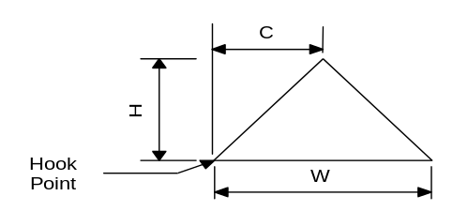
In addition to implementing the gmIShape interface, gmTriangle provides the following public member functions.
gmTriangle
gmTriangle();
Default constructor. Creates a triangle with its height, width, and offset equal to zero. The hook point is placed at (0,0).
gmTriangle
gmTriangle(const gpPoint2d& hookPnt,
Float64 h,
Float64 w,
Float64 c = 0.,
Float64 rotAngle = 0.);
Explicit constructor. Creates a triangle with height h, width w, and offset c. The hook point is positioned at hookPnt. The triangle can be rotated by rotAngle.
~gmTriangle
virtual ~gmTriangle();
Destructor.
SetHookPoint
gpPoint2d SetHookPoint(const gpPoint2d& hookPnt);
Sets the location of the hook point to hookPnt. Returns the previous value.
GetHookPoint
gpPoint2d GetHookPoint() const;
Returns the location of the hook point.
SetHeight
Float64 SetHeight(Float64 h);
Sets the height of the triangle. Returns the previous value.
GetHeight
Float64 GetHeight() const;
Returns the height of the triangle.
SetWidth
Float64 SetWidth(Float64 h);
Sets the width of the triangle. Returns the previous value.
GetWidth
Float64 GetWidth() const;
Returns the width of the triangle.
SetOffset
Float64 SetOffset(Float64 c);
Sets the offset of the triangle. Returns the previous value.
GetOffset
Float64 GetOffset() const;
Returns the offset of the triangle.
SetRotationAngle
Float64 SetRotationAngle(Float64 rotAngle);
Sets the rotation angle of the triangle. The triangle is rotated about its hook point. Returns the previous value.
GetRotationAngle
Float64 GetRotationAngle() const;
Returns the rotation angle of the triangle.

Protected Interface - Member Functions
gmTriangle
gmTriangle(const gmTriangle& rOther);
Copy constructor. Creates a triangle that is identical to rOther.
operator =
gmTriangle& operator=(const gmTriangle & rOther);
Assignment operator. Returns a reference to this triangle.

Implementation Notes

Rotate and the Rotation Angle
When the base class Rotate() method is called, the rotation angle must be updated.

gmCircle
Derived from gmShapeImp, this class represents a circle primitive. The circle is described by radius. The hook point is at the center of the circle.

Public Interface - Member Functions
In addition to implementing the gmIShape interface, gmCircle provides the following public member functions.
gmCircle
gmCircle();
Default constructor. Creates a circle with its radius equal to zero, with its center at (0,0).
gmCircle
gmCircle(const gpPoint2d& center, Float64 radius);
Explicit constructor. Creates a circle with a radius of radius, centered at point center.
~gmCircle
virtual ~gmCircle();
Destructor.
SetHookPoint
gpPoint2d SetHookPoint(const gpPoint2d& hookPnt);
Sets the location of the hook point to hookPnt. Returns the previous hook point location.
GetHookPoint
gpPoint2d GetHookPoint() const;
Returns the location of the hook point.
SetRadius
Float64 SetRadius(Float64 radius);
Sets the radius of the circle. Returns the previous radius.
GetRadius
Float64 GetRadius(Float64 radius);
Returns the radius of the circle.

Protected Interface - Member Functions
gmCircle
gmCircle(const gmCircle& rOther);
Copy constructor. Creates a circle that is identical to rOther.
operator =
gmCircle& operator=(const gmCircle& rOther);
Assignment operator. Assigns the radius and center point of rOther to this circle. Returns a reference to this circle.

gmPrecastBeam
Derived from gmShapeImp, this class represents the shape of a precast beam. Precast beams are typically found in bridge structures. A precast beam is described by its dimensions as shown in the accompanying figure. The hook point is located at the center of the top edge of the shape.
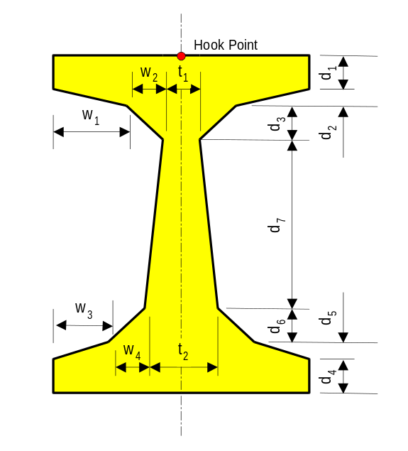

Public Interface - Member Functions
In addition to implementing the gmShapeImp interface, gmPrecastBeam provides the following public member functions.
gmPrecastBeam
gmPrecastBeam();
Default constructor. Creates an I-beam shape with all its dimensions set to zero and its hook point at (0,0). The default dimensions are not consistent.
gmPrecastBeam
gmPrecastBeam(Float64 w1, Float64 w2, Float64 w3, Float64 w4,
Float64 d1, Float64 d2, Float64 d3,
Float64 d4, Float64 d5, Float64 d6,
Float64 d7,
Float64 t1, Float64 t2
const gpPoint2d& hookPnt);
Explicit constructor. Creates an I-beam shape with the given dimensions. The hook point is positioned at hookPnt. All beam dimensions must be nonnegative. A negative dimension will result in a sysProgrammingError exception being thrown.
SetHookPoint
gpPoint2d SetHookPoint(const gpPoint2d& hookPnt);
Sets the location of the hook point to hookPnt. Returns the previous hook point location.
GetHookPoint
gpPoint2d GetHookPoint() const;
Returns the location of the hook point.
SetW1
Float64 SetW1(Float64 w1);
Sets w₁. Returns the previous value of w₁. Must be nonnegative.
GetW1
Float64 GetW1() const;
Returns the current value of w₁.
SetW2
Float64 SetW2(Float64 w2);
Sets w₂. Returns the previous value of w₂. Must be nonnegative.
GetW2
Float64 GetW2() const;
Returns the current value of w₂.
SetW3
Float64 SetW3(Float64 w3);
Sets w₃. Returns the previous value of w₃. Must be nonnegative.
GetW3
Float64 GetW3() const;
Returns the current value of w₃.
SetW4
Float64 SetW4(Float64 w4);
Sets w₄. Returns the previous value of w₄. Must be nonnegative.
GetW4
Float64 GetW4() const;
Returns the current value of w₄.
SetD1
Float64 SetD1(Float64 d1);
Sets d₁. Returns the previous value of d₁. Must be nonnegative.
GetD1
Float64 GetD1() const;
Returns the current value of d₁.
SetD2
Float64 SetD2(Float64 d2);
Sets d₂. Returns the previous value of d₂. Must be nonnegative.
GetD2
Float64 GetD2() const;
Returns the current value of d₂.
SetD3
Float64 SetD3(Float64 d3);
Sets d₃. Returns the previous value of d₃. Must be nonnegative.
GetD3
Float64 GetD3() const;
Returns the current value of d₃.
SetD4
Float64 SetD4(Float64 d4);
Sets d₄. Returns the previous value of d₄. Must be nonnegative.
GetD4
Float64 GetD4() const;
Returns the current value of d₄.
SetD5
Float64 SetD5(Float64 d5);
Sets d₅. Returns the previous value of d₅. Must be nonnegative.
GetD5
Float64 GetD5() const;
Returns the current value of d₅.
SetD6
Float64 SetD6(Float64 d6);
Sets d₆. Returns the previous value of d₆. Must be nonnegative.
GetD6
Float64 GetD6() const;
Returns the current value of d₆.
SetD7
Float64 SetD7(Float64 d7);
Sets d₇. Returns the previous value of d₇. Must be nonnegative.
GetD7
Float64 GetD7() const;
Returns the current value of d₇.
SetT1
Float64 SetT1(Float64 t1);
Sets t₁. Returns the previous value of t₁. Must be nonnegative.
GetT1
Float64 GetT1() const;
Returns the current value of t₁.
SetT2
Float64 SetT2(Float64 t2);
Sets t₂. Returns the previous value of t₂. Must be nonnegative.
GetT2
Float64 GetT2() const;
Returns the current value of t₂.
GetHeight
Float64 GetHeight() const;
Returns the current height of the section.
GetAvgWebWidth
Float64 GetAvgWebWidth() const;
Returns the average web width.
GetTopFlangeWidth
Float64 GetTopFlangeWidth() const;
Returns the top flange width
GetBottomFlangeWidth
Float64 GetBottomFlangeWidth() const;
Returns the Bottom flange width

Protected Interface - Member Functions
gmPrecastBeam
gmPrecastBeam(const gmPrecastBeam& rOther);
Copy constructor. Creates a precast beam shape with the same dimensions as rOther.
operator =
gmPrecastBeam& operator=(const gmPrecastBeam& rOther);
Assignment operator. Assigns the dimensions of rOther are assigned to the dimensions of this shape. This shape’s hook point is positioned at rOther’s hook point.

gmTrafficBarrier
Derived from gmShapeImp, this class represents the shape of a traffic barrier. Traffic barriers are typically found in bridge structures. A traffic barrier is described by its dimensions as shown in the accompanying figure.
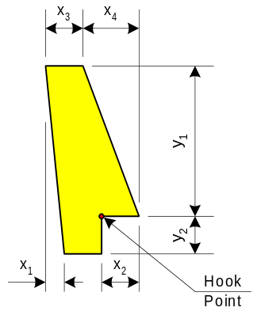

Public Interface - Member Functions
In addition to implementing the gmShapeImp interface, gmTrafficBarrier provides the following public member functions.
gmTrafficBarrier
gmTrafficBarrier();
Default constructor. Creates a traffic barrier shape with all its dimensions set to zero and its hook point at (0,0). The default dimensions are not consistent.
gmTrafficBarrier
gmTrafficBarrier(Float64 x1, Float64 x2, Float64 x3, Float64 x4,
Float64 y1, Float64 y2,
const gpPoint2d& hookPnt);
Explicit constructor. Creates a traffic barrier shape with the given dimensions. The hook point is positioned at hookPnt. All dimensions must be nonnegative. A negative dimension will result in a sysProgrammingError exception being thrown.
SetHookPoint
gpPoint2d SetHookPoint(const gpPoint2d& hookPnt);
Sets the location of the hook point to hookPnt. Returns the previous hook point location.
GetHookPoint
gpPoint2d GetHookPoint() const;
Returns the location of the hook point.
SetX1
Float64 SetX1(Float64 x1);
Sets x₁. Returns the previous value of x₁. Must be nonnegative.
GetX1
Float64 GetX1() const;
Returns the current value of x₁.
SetX2
Float64 SetX2(Float64 x2);
Sets x₂. Returns the previous value of x₂. Must be nonnegative.
GetX2
Float64 GetX2() const;
Returns the current value of x₂.
SetX3
Float64 SetX3(Float64 x3);
Sets x₃. Returns the previous value of x₃. Must be nonnegative.
GetX3
Float64 GetX3() const;
Returns the current value of x₃.
SetX4
Float64 SetX4(Float64 x4);
Sets x₄. Returns the previous value of x₄. Must be nonnegative.
GetX4
Float64 GetX4() const;
Returns the current value of x₄.
SetY1
Float64 SetY1(Float64 y1);
Sets y₁. Returns the previous value of y₁. Must be nonnegative.
GetY1
Float64 GetY1() const;
Returns the current value of y₁.
SetY2
Float64 SetY2(Float64 y2);
Sets y₂. Returns the previous value of y₂. Must be nonnegative.

Protected Interface - Member Functions
gmTrafficBarrier
gmTrafficBarrier(const gmTrafficBarrier& rOther);
Copy constructor. Creates a traffic barrier shape with the same dimensions as rOther.
operator =
gmTrafficBarrier& operator=(const gmTrafficBarrier& rOther);
Assignment operator. Assigns the dimensions of rOther are assigned to the dimensions of this shape. This shape’s hook point is positioned at rOther’s hook point.

gmShapeListener
Provides a callback interface for shape observers. When a shape changes, a listener is notified through the callback methods in this interface. Each callback is implemented with a do-nothing function. Subclasses need only override those events they are interested in listening to.
In addition to the interface specified below, this class implements the standard listener interface.

Public Interface - Member Functions
gmShapeListener
gmShapeListener()
Default constructor
~gmShapeListener
virtual ~gmShapeListener();
Destructor.
OnRegistered
virtual void OnRegistered(const gmIShape* pShape);
Called by the shape (broadcaster) pointed to by pShape when this listener is registered.
OnUnregistered
virtual void OnUnregistered(const gmIShape* pShape);
Called by the shape (broadcaster) pointed to by pShape when this listener is registered.
OnUpdate
virtual void OnUpdate(const gmIShape* pShape, Int32 lHint)=0;
Called by the subject gmIShape object whenever it changes. lHint contains one or more of the following hints.
#define DISPLAY 0x0001
#define PROPERTIES 0x0002

gmProperties
This class encapsulates the geometric properties of a shape and provides property transformation services.
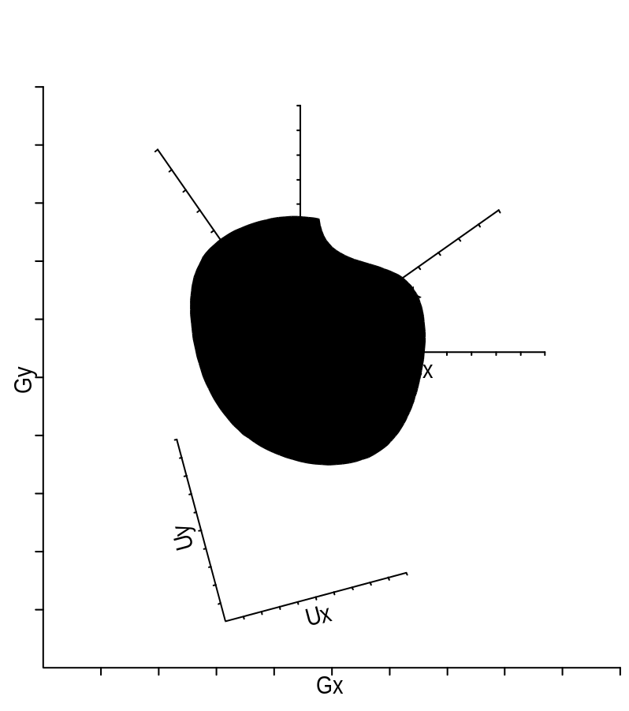
The above figure shows the four possible coordinate systems that properties can be transformed into: Global (Gx, Gy), Centroidal (Cx,Cy), Principal (Px,Py), and User-Defined (Ux,Uy). The geometric properties can be transformed to any user-defined coordinate system by changing the origin and rotation parameters.

Public Interface - Member Functions
gmProperties
gmProperties();
Default constructor. Initializes all the properties to zero. The origin of the coordinate system is global (0,0) and the orientation angle is zero.
gmProperties
gmProperties(Float64 area,
const gpPoint2d& centroid,
Float64 ixx, Float64 iyy, Float64 ixy,
Float64 yTop, Float64 yBottom,
Float64 xLeft, Float64 xRight);
Explicit constructor. Initializes the coordinate system and shape properties in the Centroidal coordinate system to the given values.
gmProperties
gmProperties(const gmProperties& rOther);
Copy constructor. Initializes this gmProperties object with the properties of rOther.
~gmProperties
~gmProperties();
Destructor. This destructor is not virtual. It is not envisioned that this class will be extended through inheritance.
operator =
gmProperties& operator=(const gmProperties& rOther);
Assignment operator. Assigns the properties of rOther to this gmProperties object. Returns a reference to this.operator ==
operator==
bool oprator == (const gmProperties& rOther) const;
Returns true if this gmProperties object is equal to the rOther gmProperties object, otherwise returns false.
operator !=
bool operator != (const gmProperties& rOther) const;
Returns false if this gmProperties object is equal to the rOther gmProperties object, otherwise returns true.
operator +
gmProperties operator+ (const gmProperties& rhs) const;
Adds the rhs properties to this (taking parallel axis theorem into consideration). The bounding boxes are unioned together.
operator +=
gmProperties& operator+= (const gmProperties& rhs);
Adds the rhs properties to this (taking parallel axis theorem into consideration). The bounding boxes are unioned together.
SetArea
Float64 SetArea(Float64 area);
Sets the area of the shape. Returns the old area.
SetCentroid
gpPoint2d SetCentroid(gpPoint2d cent);
Sets the centroid of the shape, measured in current coordinates. Returns the old centroid.
SetIxx
Float64 SetIxx(Float64 ixx);
Sets the moment of inertia about the x axis of the current coordinate system. Returns the old Ixx.
SetIyy
Float64 SetIyy(Float64 iyy);
Sets the moment of inertia about the y axis of the current coordinate system. Returns the old Ixx.
SetIxy
Float64 SetIxy(Float64 ixy);
Returns the product of inertia about the current coordinate system. Returns the old Ixx.
SetYtop
Float64 SetYtop(Float64 ytop);
Sets the distance from the centroid to the top edge of the bounding rectangle. This distance is always given using the centroidal orientation. Returns the old value.
SetYbottom
Float64 SetYbottom(Float64 ybot);
Sets the distance from the centroid to the bottom edge of the bounding rectangle. This distance is always given using the centroidal orientation. Returns the old value.
SetXleft
Float64 SetXleft(Float64 xleft);
Sets the distance from the centroid to the left edge of the bounding rectangle. This distance is always given using the centroidal orientation. Returns the old value.
SetXright
Float64 SetXright(Float64 xright);
Sets the distance from the centroid to the right edge of the bounding rectangle. This distance is always given using the centroidal orientation. Returns the old value.
Area
Float64 Area() const;
Returns the area of the shape.
Centroid
gpPoint2d Centroid() const;
Returns the centroid of the shape, measured in current coordinates.
Ixx
Float64 Ixx() const;
Returns the moment of inertia about the x axis of the current coordinate system.
Iyy
Float64 Iyy() const;
Returns the moment of inertia about the y axis of the current coordinate system.
Ixy
Float64 Ixy() const;
Returns the product of inertia about the current coordinate system.
Ytop
Float64 Ytop() const;
Returns the distance from the centroid to the top edge of the bounding rectangle. This distance is always given using the centroidal orientation.
Ybottom
Float64 Ybottom() const;
Returns the distance from the centroid to the bottom edge of the bounding rectangle. This distance is always given using the centroidal orientation.
Xleft
Float64 Xleft() const;
Returns the distance from the centroid to the left edge of the bounding rectangle. This distance is always given using the centroidal orientation.
Xright
Float64 Xright() const;
Returns the distance from the centroid to the right edge of the bounding rectangle. This distance is always given using the centroidal orientation.
I11
Float64 I11() const;
Return the principal moment of inertia about the 1-1 axis.
I22
Float64 I22() const;
Returns the principal moment of inertia about the 2-2 axis.
I12Max
Float64 I12Max() const;
Returns the maximum product of inertia for the principal coordinate system.
I12Min
Float64 I12Min() const;
Returns the minimum product of inertia for the principal coordinate system.
PrincipalDirection
Float64 PrincipalDirection() const;
Returns the direction of the principal coordinate system, measured as an angle from the global X axis to the 11 axis in radians.
SetCoordinateSystem
void SetCoordinateSystem(gmProperties::CoordSystemType sys);
Sets the type of the coordinate system that properties are to be calculated in. This call will change the location of the coordinate system to the location of the type specified unless the type is UserDefined. A type of UserDefined will not move the current coordinate system, but will change the type returned by GetCoordinateSystem to UserDefined.
GetCoordinateSystem
gmProperties::CoordSystemType GetCoordinateSystem() const;
Returns the type of the coordinate system that properties are calculated in.
SetOrigin
void GetOrigin(const gpPoint2d& origin);
Sets the current origin of the coordinate system for which properties are calculated with respect to. This also sets the coordinate system type to UserDefined.
GetOrigin
gpPoint2d GetOrigin() const;
Returns the location of the origin of the current coordinate system for which the properties are defined with respect to. The origin point is always located in global coordinates.
SetOrientation
void Orientation(Float64 angle) const
Sets the current orientation of the coordinate system for which the properties are defined with respect to. The orientation angle is measured in radians, counter clockwise from the positive global X axis.
GetOrientation
Float64 GetOrientation() const;
Returns the current orientation of the coordinate system for which the properties are defined with respect to. The orientation angle is measured in radians, counter clockwise from the positive global X axis.

Public Interface - Enumerations
CoordSystemType
enum gmProperties::CoordSystemType{
Centroidal, // Origin at centroid of shape and
// oriented in global coords
Global, // Origin at global origin
Principal, // Origin at centroid of shape and
//oriented in principal direction
UserDefined} // Origin and orientation set by user
Enum which defines the currently set coordinate system.

gmPolyPointIter
This is a helper class used to iterate through the points in a gmPolygon object. gmPolyPointIter does an insertion order traversal of the points in the gmPolygon it is associated with.

Public Interface - Member Functions
The gmPolyPointIter class will implement the standard iterator methods Begin(), End(), Next(),and operator void *(). The standard GetCurrent() iterator method for this class is described below.
gmPolyPointIter
gmPolyPointIter();
Default constructor. An iterator created with this constructor is not associated with a polygon. Attempting to iterate with this iterator is safe, though it doesn’t do anything. Calls to CurrentPoint() will return a null pointer. To associate this iterator with a polygon use SetPolygon().
gmPolyPointIter
gmPolyPointIter(const gmPolygon* pPolygon);
Explicit constructor. Creates an iterator that iterates through the points in pPolygon.
operator=
gmPolyPointIter& operator=(const gmPolyPointIter& rOther);
Assignment operator.
SetPolygon
void SetPolygon(const gmPolygon* pPolygon);
Sets the polygon for iteration. Sets the iterator position to Begin().
CurrentPoint
const gpPoint2d* CurrentPoint() const;
Returns a pointer to the constant current point or a null pointer if nothing exists.
CurrentKey
const Uint32* CurrentKey() const;
Returns a pointer to the current key. If there is not a current element, returns 0.

Implementation Notes

Non-Const PolyPoint Iterator
A non-const version of the iterator is not supplied because the polygon has no way of knowing if one of its points has been changed.

gmShapeIter
This is a helper class used to iterate through the shapes in a gmCompositeShape object. This iterator can be used to alter the shapes in the composite.
The gmShapeIter class will implement the standard iterator methods Begin(), End(), Next(),and operator void *(). The standard GetCurrent() iterator method for this class is described below.

Public Interface - Member Functions
gmShapeIter
gmShapeIter();
Default constructor. An iterator created with this constructor is not associated with a composite shape. Attempting to iterate with this iterator is safe, though it doesn’t do anything. To associate this iterator with a composite shape use SetComposite().
gmShapeIter
gmShapeIter(gmCompositeShape* pComposite);
Explicit constructor. Creates an iterator that iterates through the shapes in pComposite. Sets the iterator position to Begin().
operator=
gmShapeIter& operator=(const gmShapeIter& rOther);
Assignment operator.
SetComposite
void SetComposite(gmCompositeShape* pComposite);
Sets the composite for iteratoration. Sets the iterator position to Begin().
CurrentShape
gmIShape* CurrentShape() const;
Returns a pointer to the current shape. Returns null if no shape is there.
CurrentKey
const Uint32* CurrentKey() const;
Returns a pointer to the key for the current point. Returns zero if no shape is there.

gmConstShapeIter
This is a helper class used to iterate through the shapes in a gmCompositeShape object. This iterator can not be used to alter the shapes in the composite.
The gmConstShapeIter class will implement the standard iterator methods Begin(), end(), Next(),and operator void *(). The standard GetCurrent() iterator method for this class is described below.

Public Interface - Member Functions
gmConstShapeIter
gmConstShapeIter();
Default constructor. An iterator created with this constructor is not associated with a composite shape. Attempting to iterate with this iterator is safe, though it doesn’t do anything. To associate this iterator with a composite shape use SetComposite().
gmConstShapeIter
gmConstShapeIter(const gmCompositeShape* pComposite);
Explicit constructor. Creates an iterator that iterates through the shapes in pComposite. Sets the iterator position to Begin().
operator=
gmConstShapeIter& operator=(const gmConstShapeIter& rOther);
Assignment operator.
SetComposite
void SetComposite(const gmCompositeShape* pComposite);
Sets the composite for iterattion. Sets the iterator position to Begin().
CurrentShape
const gmIShape* CurrentShape() const;
Returns a pointer to constant shape. The pointer is null if no shape is there.
CurrentKey
const Uint32* CurrentKey() const;
Returns a pointer to the key for the current point. The key is zero if no shape is there.

gmSection
A section is a collection of internal components of a structural member. Each component consists of a shape and some associated material properties. A component can be designated as structural or non-structural. Non-structural components do not contribute to the elastic or transformed properties of a section, they do however contribute to the mass properties.
In addition to the interface specified below, this class implements the standard broadcaster interface.
Calculation of transformed properties of a section are not directly supported because gmSection is a low-level component and transformed property calculations are often domain-specific and specification-dependent. However, gmSection can be indirectly used to calculate transformed properties by using an n-factor in place of modE as the modulus of elasticity for each of the components. The transformed properties then become equivalent to the elastic properties. “Equivalent density” can then be easily calculated by dividing the mass per unit length by the transformed area.

Public Interface - Member Functions
gmSection
gmSection();
Default constructor. Create a section does not have any components.
~gmSection
virtual ~gmSection();
Destructor.
Translate
void Translate(const gpSize2d& delta);
Translates a section by a delta amount by translating all the pieces currently in the section.
Rotate
void Rotate(const gpPoint2d& center, Float64 angle);
Rotates the section about a point by rotating all the pieces currently in the section. The section is rotated by an amount angle, measured in radians counter clockwise from the positive X-axis.
AddComponent
Uint32 AddComponent(const gmIShape& rShape,
Float64 modE, Float64 density,
bool bIsStructural = true,
bool bRegisterListeners = false);
Adds a component to the section. A component consists of a shape (a clone of rShape) and the material properties modE and density. This method creates a clone of rShape. If bRegisterListeners is true, listeners registered with rShape are registered with the clone as well. If a shape is modified, section listeners will be notified through the gmSectionListener interface. A lookup key is returned. This key is used to access the clone of the shape or its associated material properties.
GetComponent
const gmSectionComponent* GetComponent(Uint32 key) const;
gmSectionComponent* GetComponent(Uint32 key);
Returns a pointer to a component identified by key. If the component could not be found 0 is returned .
RemoveComponent
bool RemoveComponent(Uint32 key);
Removes a component (shape and material) from the section and frees the memory allocated by the call to CreateClone() in AddComponent(). If the component could not be found, this method does nothing (the debugging version issues a WARNing). Returns true if the component was successfully removed, otherwise false.
GetElasticProperties
void GetElasticProperties(gmElasticProperties* pProperties) const;
Assigns the elastic properties of the section to the gmElasticProperties object pointed to by pProperties.
GetMassProperties
void GetMassProperties(gmMassProperties* pProperties) const;
Assigns the mass properties of the section to the gmMassProperties object pointed to by pProperties.
GetBoundingBox
gpRect2d GetBoundingBox(bool bExcludeNonstructuralComponents) const;
Returns the smallest rectangle that bounds the entire section. If bExcludeNonstructualComponents is true, the bounding box is the smallest rectangle that bounds all of the structural components.
IsContained
gmSection::Containment IsContained(const gpPoint2d& p) const;
Tests if point p is contained within the boundary of the section. Returns the containment state of point p.
Implement only if needed
CreateClippedSection
gmSection* CreateClippedSection(const gpLine2d& line,
gpLine2d::Side side
) const;
Clips this section against line. Clips away the portion of the shape on the side of the line defined by side. This is a factory method. You are responsible for freeing the memory allocated by this method. If shape s lies entire on the clipping side of the line 0 is returned. Any listeners to the original section are not transferred to this new section.
CreateClippedSection
gmSection* CreateClippedSection(const gpRect2d& r,
gmSection::ClipRegion& region
) const;
Clips this section against rectangle r. Clips in or out of the rectangle as specified by region. This is a factory method. You are responsible for freeing memory allocated by this method. This method returns 0 if, the shape lies entirely within the clipping rectangle and region is set to clip out, or the shape and the rectangle do not intersection and region is to clip in. Any listeners to the original section are not transferred to this new section.
EnableBorderMode
void EnableBorderMode(bool bEnable);
Enables or disables the border drawing mode of the composite. This method enables/disables the border mode of all the shapes currently in the composite.
SetBorderColor
void SetBorderColor(COLORREF color);
Sets the border color of all the shapes currently in the composite to color. Returns the previous color setting.
EnableFillMode
void EnableFillMode(bool bEnable);
Sets the fill mode of the composite. This method sets the fill mode of all the shapes currently in the composite. All shapes subsequently added to the composite will have their fill mode set as well. Returns the previous fill mode setting.
SetFillColor
void SetFillColor(COLORREF color);
Sets the fill color of all the shapes currently in the composite to color. Returns the previous color setting.
Draw
void Draw(HDC hDC, const grlibPointMapper& mapper) const;
Draws the composite by calling Draw() for every shape in the composite.

Protected Interface - Member Functions
gmSection
gmSection(const gmSection& rOther);
Copy constructor. Creates a section that is a copy of rOther.
operator =
gmSection& operator=(const gmSection& rOther);
Assignment operator.

Implementation Notes

Computing Section Properties
The various section properties provided by this package can all be computed through the public interface of gmSectionComponent and gmIShape. This gives us a perfect opportunity to insulate our clients from implementation details. The property calculations can be done in the cpp file scope of the Section component (component being physical software component in this case), either with free functions or helper classes. Clients of this package will be totally insulated from the details of the property calculations.
A different strategy for computing section properties would be to remove the GetXxxProperties() calls from gmSection and put them in gmUtil (changing the name to ComputeXxxProperties() ). This would de-couple the operations performed on a gmSection from the section object itself. (gmUtil::ComputeElasticProperties(&ep, my_section); ). The downside is gmSection isn’t left with any interesting functionality, just component management and Draw(). Maybe this is a sign that we’ve exposed too much of the implementation of gmSection?

gmSectionComponent
A gmSectionComponent object provides a wrapper around the shape, material properties, and structural-ness of a component in a section.

Public Interface - Member Functions
gmSectionComponent
gmSectionComponent(gmIShape* pShape,
Float64 modE, Float64 density,
bool bIsStructural);
Explicit constructor. Constructs a component wrapper. The wrapper assumes ownership of the memory pointed to by pShape.
~gmSectionComponent
~gmSectionComponent();
Destructor. Deletes the shape and material objects owned by this component.
GetShape
const gmIShape& GetShape() const;
gmIShape& GetShape();
Returns a reference to the shape of this component.
GetModE
Float64 GetModE() const;
Returns the modulus of elasticity of the material.
SetModE
Float64 SetModE(Float64 modE);
Sets the modulus of elasticity of the material. Returns the old modulus.
GetDensity
Float64 GetDensity() const;
Returns the density of the material.
SetDensity
Float64 SetDensity(Float64 density);
Sets the density of the material. Returns the old density.
MakeStructural
void MakeStructural();
Makes this component structural. Structural components contribute to the mass, elastic, and transformed properties of the section.
MakeNonstructural
void MakeNonstructural();
Makes this component non-structural. Non-structural components contribute only to the mass properties of the section.
IsStructural
bool IsStructural()const;
Returns true if this component is structural, otherwise returns false.

Implementation Notes

Ownership
A gmSectionComponent object owns the shape it represents. This class is a wrapper so that the shape, associated material properties, and structural-ness of a component can be presented to a gmSection client in a neatly bundled package. We don’t care if clients create their own gmSectionComponent objects, we just can’t allow them to insert a gmSectionComponent into a gmSection.

Dirty-state Management
When a component is changed, either directly or indirectly, the dirty state of the parent section must be maintained. One possible implementation is to have gmSectionComponent be a listener of its shape. If the shape changes, gmSectionComponent could notify the section. Likewise, if the structural-ness of the component changes it could notify the section. Since dirty-ness is an implementation detail of a section, gmSectionComponent will have to be granted friendship to access the internal member functions needed to manipulate the dirty flags.

gmElasticProperties
This class encapsulates the elastic properties of a section and provides property transformation services.
The elastic properties can be transformed to another coordinate system Similar to how the gmProperties class may be changed.

Public Interface - Member Functions
gmElasticProperties
gmElasticProperties();
Default constructor. Initializes all the properties to zero. The origin of the coordinate system is global (0,0) and the orientation angle is zero.
gmElasticProperties
gmElasticProperties(Float64 eArea,
const gpPoint2d& centroid,
Float64 eIxx, Float64 eIyy, Float64 eIxy,
Float64 yTop, Float64 yBottom,
Float64 xLeft, Float64 xRight);
Explicit constructor. Initializes the section properties to the given values in the section’s centroidal coordinate system.
gmElasticProperties
gmElasticProperties(const gmElasticProperties& rOther);
Copy constructor. Initializes this gmElasticProperties object with the properties of rOther.
~gmElasticProperties
~gmElasticProperties();
Destructor. This destructor is not virtual. It is not envisioned that this class will be extended through inheritance.
operator =
gmElasticProperties& operator=(const gmElasticProperties& rOther);
Assignment operator. Assigns the properties of rOther to this gmElasticProperties object. Returns a reference to this.
operator==
bool oprator == (const gmElasticProperties& rOther) const;
Returns true if this gmElasticProperties object is equal to the rOther gmElasticProperties object, otherwise returns false.
operator !=
bool operator != (const gmElasticProperties& rOther) const;
Returns false if this gmElasticProperties object is equal to the rOther gmElasticProperties object, otherwise returns true.
operator +
gmElasticProperties operator+ (const gmElasticProperties& rhs) const;
Adds the rhs properties to this (taking parallel axis theorem into consideration). The bounding boxes are unioned together.
operator +=
gmElasticProperties& operator+= (const gmElasticProperties& rhs);
Adds the rhs properties to this (taking parallel axis theorem into consideration). The bounding boxes are unioned together.
SetEA
Float64 SetEA(Float64 eA);
Sets the area of the shape. Returns the old area.
SetCentroid
gpPoint2d SetCentroid(gpPoint2d cent);
Sets the centroid of the shape, measured in current coordinates. Returns the old centroid.
SetEIxx
Float64 SetEIxx(Float64 eIxx);
Sets the moment of inertia about the x axis of the current coordinate system. Returns the old EIxx.
SetEIyy
Float64 SetEIyy(Float64 eIyy);
Sets the moment of inertia about the y axis of the current coordinate system. Returns the old EIyy.
SetEIxy
Float64 SetEIxy(Float64 eIxy);
Returns the product of inertia about the current coordinate system. Returns the old EIxy.
SetYtop
Float64 SetYtop(Float64 ytop);
Sets the distance from the centroid to the top edge of the bounding rectangle. This distance is always given using the centroidal orientation. Returns the old value.
SetYbottom
Float64 SetYbottom(Float64 ybot);
Sets the distance from the centroid to the bottom edge of the bounding rectangle. This distance is always given using the centroidal orientation. Returns the old value.
SetXleft
Float64 SetXleft(Float64 xleft);
Sets the distance from the centroid to the left edge of the bounding rectangle. This distance is always given using the centroidal orientation. Returns the old value.
SetXright
Float64 SetXright(Float64 xright);
Sets the distance from the centroid to the right edge of the bounding rectangle. This distance is always given using the centroidal orientation. Returns the old value.
EA
Float64 EA() const;
Returns the axial stiffness of the section.
Centroid
gpPoint2d Centroid() const;
Returns the centroid of the structural section, measured in the current coordinate system.
EIxx
Float64 EIxx() const;
Returns the moment of inertia about the horizontal axis of the current coordinate system.
EIyy
Float64 EIyy() const;
Returns the moment of inertia about the vertical axis of the the current coordinate system..
EIxy
Float64 EIxy() const;
Returns the product of inertia about the the current coordinate system.
Ytop
Float64 Ytop() const;
Returns the distance from the centroid to the top edge of the bounding rectangle This distance is always given using the centroidal orientation.
Ybottom
Float64 Ybottom() const;
Returns the distance from the centroid to the bottom edge of the bounding rectangle. This distance is always given using the centroidal orientation.
Xleft
Float64 Xleft() const;
Returns the distance from the centroid to the left edge of the bounding rectangle. This distance is always given using the centroidal orientation.
Xright
Float64 Xright() const;
Returns the distance from the centroid to the right edge of the bounding rectangle. This distance is always given using the centroidal orientation.
EI11
Float64 EI11() const;
Return the principal moment of inertia about the 1-1 axis.
EI22
Float64 EI22() const;
Returns the principal moment of inertia about the 2-2 axis.
EI12Max
Float64 EI12Max() const;
Returns the maximum product of inertia for the principal coordinate system.
EI12Min
Float64 EI12Min() const;
Returns the minimum product of inertia for the principal coordinate system.
PrincipalDirection
Float64 PrincipalDirection() const;
Returns the direction of the principal coordinate system, measured as an angle from the global X to the 11 axis in radians.
SetCoordinateSystem
void SetCoordinateSystem(gmElasticProperties::CoordSystemType sys);
Sets the type of the coordinate system that properties are to be calculated in. This call will change the location of the coordinate system to the location of the type specified unless the type is UserDefined. A type of UserDefined will not move the current coordinate system, but will change the type returned by GetCoordinateSystem to UserDefined.
GetCoordinateSystem
gmElasticProperties::CoordSystemType GetCoordinateSystem() const;
Returns the type of the coordinate system that properties are calculated in.
SetOrigin
void GetOrigin(const gpPoint2d& origin);
Sets the current origin of the coordinate system for which properties are calculated with respect to. This also sets the coordinate system type to UserDefined.
GetOrigin
gpPoint2d GetOrigin() const;
Returns the location of the origin of the current coordinate system for which the properties are defined with respect to. The origin point is always located in global coordinates.
SetOrientation
void Orientation(Float64 angle) const
Sets the current orientation of the coordinate system for which the properties are defined with respect to. The orientation angle is measured in radians, counter clockwise from the positive global X axis.
GetOrientation
Float64 GetOrientation() const;
Returns the current orientation of the coordinate system for which the properties are defined with respect to. The orientation angle is measured in radians, counter clockwise from the positive global X axis.

Public Interface - Enumerations
CoordSystemType
enum gmElasticProperties::CoordSystemType{
Centroidal, // Origin at centroid of shape and
// oriented in global coords
Global, // Origin at global origin
Principal, // Origin at centroid of shape and
// oriented in principal direction
UserDefined} // Origin and orientation set by user
Enum which defines the currently set coordinate system.

gmMassProperties
This class encapsulates the mass properties of a section.

Public Interface - Member Functions
gmMassProperties
gmMassProperties();
Default constructor. Initializes all the properties to zero.
gmMassProperties
gmMassProperties(Float64 mpl);
Explicit constructor. Initializes the mass per length to mpl.
gmMassProperties
gmMassProperties(const gmMassProperties& rOther);
Copy constructor. Initializes this gmMassProperties object with the properties of rOther.
~gmMassProperties
~gmMassProperties();
Destructor. This destructor is not virtual. It is not envisioned that this class will be extended through inheritance.
operator =
gmMassProperties& operator=(const gmMassProperties& rOther);
Assignment operator. Assigns the properties of rOther to this gmMassProperties object. Returns a reference to this.
SetMassPerLength
Float64 SetMassPerLength(Float64 mpl);
Sets the mass per length of the section. Returns the old value.
MassPerLength
Float64 MassPerLength() const;
Returns the mass per length of the section.

gmSectionComponentIter
This is a helper class used to iterate through the components in a gmSection object. This iterator can be used to alter the components in the section.
The gmSectionComponentIter class will implement the standard iterator methods Begin(), End(), Next(), Move(), and operator void *(). The standard GetCurrent() iterator method for this class is described below.

Public Interface - Member Functions
gmSectionComponentIter
gmSectionComponentIter();
Default constructor. An iterator created with this constructor is not associated with a section. Attempting to iterate with this iterator is safe, though it doesn’t do anything. To associate this iterator with a section use SetSection().
gmSectionComponentIter
gmSectionComponentIter(gmSection* pSection);
Explicit constructor. Creates an iterator that iterates through the components in pSection.
operator=
gmSectionComponentIter& operator=(const gmSectionComponentIter& rOther);
Assignment operator.
SetSection
void SetSection(gmSection* pSection);
Sets the section for iteration. Sets the iterator position to First().
CurrentComponent
gmSectionComponent* CurrentComponent() const;
Returns a reference to the current component. Returns a null pointer if no component exists there.
CurrentKey
const Uint32* CurrentKey() const;
Returns a pointer to the key for the current component. Returns zero if no component exists there.

gmConstSectionComponentIter
This is a helper class used to iterate through the components in a gmSection object. This iterator can not be used to alter the components in the section.
The gmConstSectionComponentIter class will implement the standard iterator methods Begin(), End(), Next(), Move(), and operator void *(). The standard GetCurrent() iterator method for this class is described below.

Public Interface - Member Functions
gmConstSectionComponentIter
gmConstSectionComponentIter();
Default constructor. An iterator created with this constructor is not associated with a section. Attempting to iterate with this iterator is safe, though it doesn’t do anything. To associate this iterator with a section use SetSection().
gmConstSectionComponentIter
gmConstSectionComponentIter(const gmSection* pSection);
Explicit constructor. Creates an iterator that iterates through the components in pSection.
operator=
gmConstSectionComponentIter& operator=(const gmConstSectionComponentIter& rOther);
Assignment operator.
SetSection
void SetSection(const gmSection* pSection);
Sets the section for iteratoration. Sets the iterator position to First().
CurrentComponent
const gmSectionComponent* CurrentComponent() const;
Returns a reference to the current component. Returns a null pointer if no component is there.
CurrentKey
const Uint32* CurrentKey() const;
Returns a pointer to the key for the current component. Returns zero if no component is there.

gmSectionListener
Provides a callback interface for gmSection observers. When a section changes, a listener is notified through the callback methods in this interface. Each callback is implemented with a do-nothing function. Subclasses need only override those events they are interested in listening to.
In addition to the interface specified below, this class implements the standard listener interface.

Public Interface - Member Functions
gmSectionListener
gmSectionListener();
Default constructor.
~gmSectionListener
~gmSectionListener();
Destructor
OnUpdate
virtual void OnUpdate(const gmSection* pSection, Int32 lHint, const gmSectionComponent* pComp=0)=0;
Called by the subject gmSection object whenever it changes. lHint contains one or more of the following hints.
#define PROPERTIES 0x0001
#define DISPLAY 0x0002
The parameter pComp will point the gmSectionComponent in question. If pComp is zero, Then all components in the section were affected.

gmShapeUtils

Public Interface - Member Functions
GetRootNode
static gmCompositeShape* GetRootNode(gmIShape& rShape);
static const gmCompositeShape* GetRootNode(const gmIShape& rShape);
Returns a pointer to the root node in a composite shape hierarchy. If rShape is not a composite, returns 0.
Implementation Note: Don’t use recursion.
CopyTraits
static void CopyTraits(const gmShapeImp& rFrom, gmIShape* pTo);
Copy cosmetic properties from one shape to another.

gmWsdotPrecastBeam

Public Interface - Member Functions
GetInstance
static gmWsdotPrecastBeams& GetInstance();
Returns the singleton instance of gmWsdotPrecastBeams.
WxxG
const gmPrecastBeam& W74G();
const gmPrecastBeam& W58G();
const gmPrecastBeam& W50G();
const gmPrecastBeam& W42G();
const gmPrecastBeam& W74MG();
const gmPrecastBeam& W58MG();
const gmPrecastBeam& W50MG();
const gmPrecastBeam& W42MG();
Returns a reference to a precast beam shape that has the dimensions of the WSDOT standard shapes. Shapes ending with “MG” use the official WSDOT metric dimensions as given in the WSDOT BDM.

Implementation Notes
The shapes must be listeners of unitSysUnitsMgr. If the system units are changed, the dimensions of these beams must be automatically changed to match. gmPrecastBeam will need a special subclass for this purpose. This class should be kept at CPP file scope so it wont be exposed to the public. In order to save memory and program start-up time, the objects returned by the WxxG functions should be created on an on-demand basis.
In order to allow control of destruction order, gmWsdotPrecastBeams is implemented as a singleton class.

. A flyweight is a shared, fine-grained object that can be used in multiple contexts simultaneously (see Flyweight pattern)

